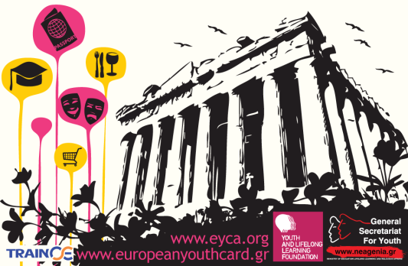
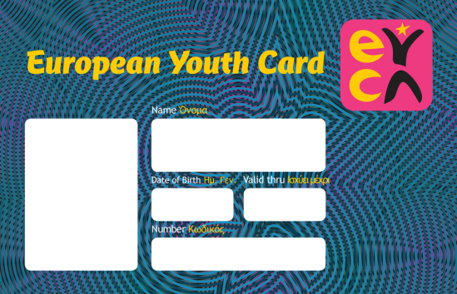

You’re young, right?
You are in Europe, right?
Did you get the European Youth Card?
The General Secretariat for Youth and Lifelong Learning and the Youth and Lifelong Learning Foundation in cooperation with the European Youth Card Association (EYCA) introduce the European Youth Card, a unique tool of information, communication and entertainment. It is a discount card, which provides 5 millions young people with considerable discounts and benefits.
European Youth Card: only for young people!
The European Youth Card is available for all young people between the ages of 13 and 30. The cost amounts to 10 Euros, which covers the subscription for one year, and it can be renewed every year until the age of 30. The European Youth Card is not a debit card but a discount card.
Discover Europe with the European Youth Card!
With the European Youth Card you can enjoy special benefits and discounts in Greece, as well as in 34 other countries! (Andorra, Armenia, Austria, Belarus, Belgium, Bulgaria, Croatia, Cyprus, Czech Republic, Estonia, Finland, Georgia, Germany, Greece, Hungary, Italy, Latvia, Liechtenstein, Lithuania, Luxembourg, Malta, Moldova, Montenegro, Netherlands, Poland Portugal, Romania, Russia, San Marino, Serbia, Slovakia, Slovenia, Spain, Sweden, Switzerland, Turkey, Ukraine and United Kingdom)
Discount Catalog
The list is huge! Get special discounts on services and products, just by showing your card, in areas such as:
Culture: movies, theaters, museums, cultural events and concerts.
Shopping: Clothing, optical, hairdressers, beauty salons, gyms, jewelers, bookstores, bikes, household items / gifts.
Entertainment / Dining: Restaurants, bars, cafes, club.
Education: language schools, secondary education, vocational training institutes, seminars, colleges.
Tourism: travel agencies, hotels, apartments, camping, car rental.
For more information regarding the available discounts please visit www.europeanyouthcard.org
How to obtain the card:
- Submit the online application. Attach a small sized passport/identity photo when asked.
- Visit our Headquarters and acquire the card instantly .
Foundation for Youth and Lifelong Learning
ACHARNON 417
11 143 Athens
Greece
For the above two ways:
For more information, please contact us at
+30 213 1314411-14

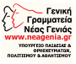
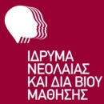
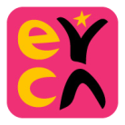
www.europeanyouthcard.gr

